**REPORT**

**PATCH MATCHING ALGORITHM UNDER SEVERE DEGRADATIONS**

**Problem Statement:**

To propose a patch matching algorithm and extending the algorithm in implementing Image inpainting.

**Aim explained In detail:**

It is problem to find the matching patch in place of a patch removed in an image based on heuristics.A dataset of images(in my case is a dataset of images of greenery) with the first file taken as the primary file in which the patch of size (20y x 20y ,where y is an integer) is removed with the centre chosen by the coordinates specified by the user.The following algorithm tries to find out the best fit image patch from all possible patches from the same image or the other images of the dataset.If the patch side length is varied,better and correct results are obtained for smaller side length patches as there will be more neighbouring patches from the dataset for comparison . Note that the algorithm can be well extended to rectilinear patches.

**Input and Output:**

In the input file,the user has to specify the following:

* Number of input images
* The dataset of input images(pathname)-#only images of type jpg,jpeg,png,ppm(P6 or P3) are allowed.
* The coordinates(w,h) of the patch from which the patch is to be removed from the first image of the dataset.#w is the pixel number from the left margin and h is the pixel no. from the top margin.

The output file contains:

* The image file with a black patch at the coordinate specified by the user.
* The resultant image file with the patch filled with the corresponding matching patch matched by the algorithm.

**Algorithm:**

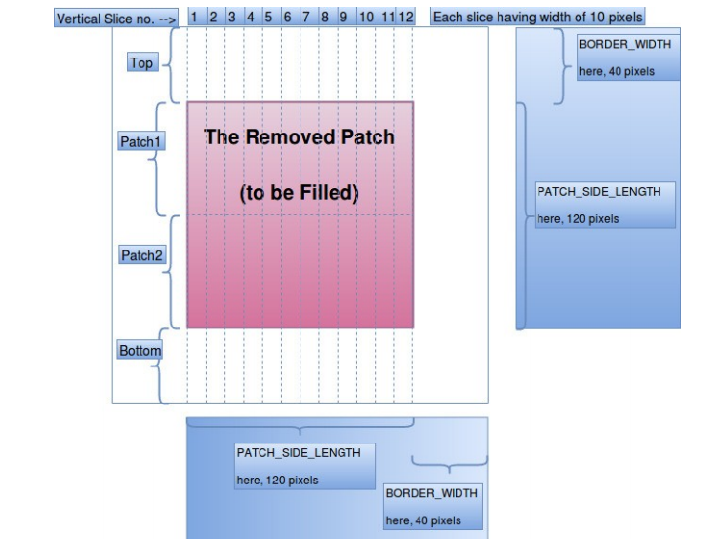

**Fig 1**.The above figure denotes the breakdown of the patch used in the algorithm.

Once the patch is removed from the primary file(which is the first file in the dataset),the function **finTraversCheck** is called which returns the best matching patch by running the algorithm.

**finTraversCheck** takes the first image with patch removed and all other images in the dataset and also the position where the patch is created in the image.For each image it takes each possible image patch (of course, of same size), adds the patch into the initial parameter image (the one with the removed patch). The algorithm works on scoring the patches.There is a score for both vertical check and horizontal check.For the dataset which i took,the score calculation involves a weightage of 0.7 to the vertical score and 0.3 to the horizontal score which gives an optimal answer.Note that this measure of weightage is only applied if score generated by horizontal check is more than that of vertical check,otherwise the score generated by vertical check is used.*This weightage measure and priority can be different for different datasets.*

**vertTraversScore()** returns the score for checking in a vertical fashion.It follows the convention of Fig 1.The patch and the top and bottom border is divided into 12 uniform vertical slices(assuming patch side is of length 120 pixels) each of length 10 pixels.Every slice is divided into 4 portions( Top, Patch1, Patch2 and Bottom,) for proper continuity checking.Instead of computing using individual pixels, I have considered means of small 10 X 10 squares (100 pixels) for computation, as individual pixels may be too discrete data for any viable computation and comparison. Each regions’ mean and variance are computed (like var_meanTop and mean_meanTop, for Top region of a vertical slice). Mean is used in the computation for comparison (continuity), and variance is used to detect (indicative only) any visibly significant pattern in the region of the vertical slice.This is a clear indication that only 1st and 2nd moments of distribution are used for matching.Using higher moments might give better results.It just increases the computational time overhead.

Here the variance of a region is denoted by v<region_name> and mean by m<region_name>(ex: vTop is for var_meanTop, and mTop – for mean_meanTop).

The score is assigned to patch based on several cases:

CASE1: vTop < 90, vPatch1 < 90 , abs(mTop – mPatch1) < 12:

Variance of Top and patch1 are less which implies patterns are visibly significant.The absolute mean difference between them is also less which implies there is a continuity in the pattern of the image.Hence ,such a distribution is wanted and the score is thus incremented by 4(this increment is inversely proportional to the difference in mean of 2 regions).

CASE2: vBottom < 90, vPatch2 < 90, abs(mBottom – mPatch2) < 12

This is also a similar argument as above for the regions Bottom and patch2.Hence the score is incremented by 4(which is again inversely proportional to the difference in means).

CASE3: vTop < 90, vPatch1 < 90, vBottom < 90, vPatch2 < 90, abs(mTop – mPatch1) < 12, abs(mBottom – mPatch2) < 12, abs(mPatch1 – mPatch2) < 15.

In this case all 4 regions viz.Top,Patch1,Bottom,Patch2 are having a proper variance and mean difference measure which is wanted.Hence the score is incremented by 8.This increment is inversely proportional to diff in means of patch1 and 2.Patterns are continous throughout the slice.

CASE4:vTop < 90, vPatch1 < 90, abs(mTop – mPatch1) > 30

Variances of top and Patch1 are low hence their patterns are visibly significant.But,the diff in means of top and patch1 is more hence the continuity is not clearly maintained which is not wanted.Therefore the score is decremented by 4,which is directly proportional to the difference of means between top and patch1.(more diff implies more discontinuity which implies more less score).

CASE5 :vBottom < 90, vPatch2 < 90, abs(mBottom – mPatch2) > 30

Variance of bottom and patch2 imply patterns are visibly significant.Difference in mean is more which is not wanted.Again score is decremented by 4 same as above case.

CASE6:vTop < 90, vBottom < 90, |mTop – mBottom| < 20, and

(abs(mTop – mPatch1) > 30 or abs(mBottom – mPatch2) > 30)

Patterns of top and bottom are visibly significant.DIfference in mean is low which implies there is a vertical continuity as we pass through top and bottom regions.But there is a discontinuity between (top and patch 1) and (bottom and patch2).

* vPatch1 < 90 and vPatch2 < 90:Variance of patch1 and patch2 are also low.Hence patterns are visibly significant(discontinuity with adjacent top and bottom regions).Score is decremented by 10 as this is highly not wanted and is a case of clear discontinuity.
* vPatch1 < 90 or vPatch2 < 90:Either of the pattern(and discontinuity) is visibly significant.Hence the score is decremented by 9.
* Both are false:Variamce of patch 1 and patch 2 are not low.So their pattern(and their discontinuity from top and bottom regions) are not so visibly significant.Hence score is decremented by 8.

Decrement is directly proportional to the max difference between means of top and patch1 and bottom and patch2.

CASE7: vTop >= 90, abs(mTop – mPatch1) < 15:

Variance of top is high,hence its pattern is not visibly significant in the vertical slice.But the diff in mean of top and patch1 is less and hence there is some kind of a weak vague continuity across the top and patch1.Hence score is incremented by 2 which is inversely proportional to the diff.

CASE8:vBottom >= 90, abs(mBottom – mPatch2)< 15:

Similar to above discussion hence the score is incremented by 2.

CASE9:vTop >= 90, vBottom >= 90, abs(mTop – mPatch1) < 15, abs(mBottom – mPatch2)< 15,

and, abs(mTop – mBottom) < 25:

The top and bottom regions have ‘high’ variance, but there is some continuity of each of them with their adjoining regions (i.e. patch1 and patch2 resp.). Also, there is some continuity between top and bottom regions too. This is also quite a desirable trait.So, the score is incremented by 2. This increment is inversely proportional to the minimum of the differences between means of top & patch1, and, bottom & patch2.

CASE10:vTop >= 90, vBottom >= 90, vPatch1 < 90, vPatch2 < 90,

abs(mTop – mPatch1) > 30, abs(mBottom – mPatch2) > 30:

The variances of top and bottom are high, but that of patch1 and patch2 are low. Also there is discontinuity bet top & patch1, and bottom & patch2.

* abs(mPatch1 – mPatch2) < 15:the discontinuity of the patch from the border (both top and bottom) is more prominent when there is continuity between the patch 1 and patch2.Hence the score is decremented by 6 which is directly proportional to the difference in means of patch 1 and 2.
* abs(mPatch1 – mPatch2) >= 15:Inspite of the discontinuity between patch and border,its no longer prominent.Hence the score is decremented by 4 which is directly proportional to the max of diff between means of (top and patch1) and (bottom and patch2).

Note:These values like 12,15 … are decided after running the code multiple times and by checking the optimal output for the forest dataset.

**horiTraversCheck** does the same thing except in the horizontal fashion.

The scores incremented or decremented are directly proportional to the difference of means of different regions.The difference is normalized between 0,1.

**Observations:**

1.)Input image:



Image with patch removed:

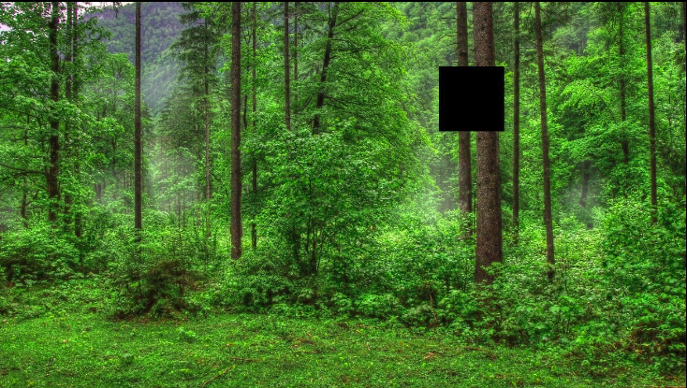

Patch filled:



2.Another patch in the same above input image:

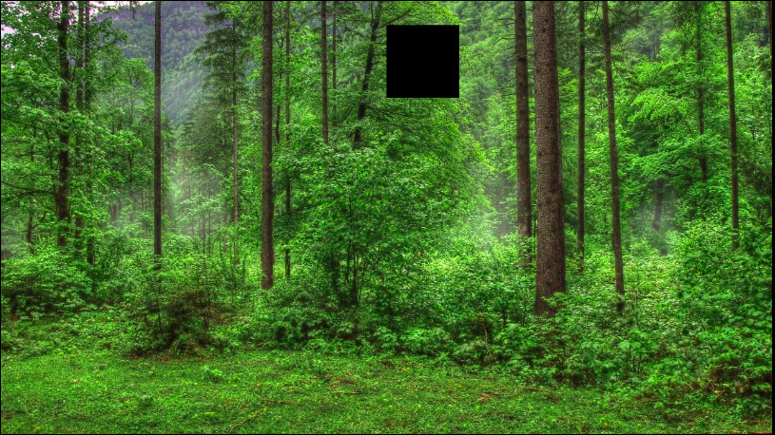

Patch filled:



Examples of Moderate fitting of patches:

Input image:



Patch created image:

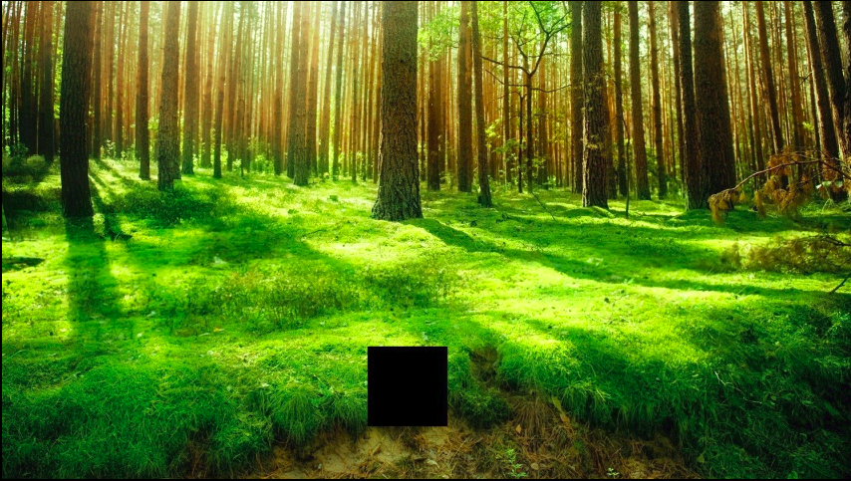

Patch filled:



The reason is the resulting patch is the best-fit patch, but still

the best-fit does not completely fit the hole (as, no better patches could be selected from any other portion of any image file).

Bad fitting:

Patch removed image:

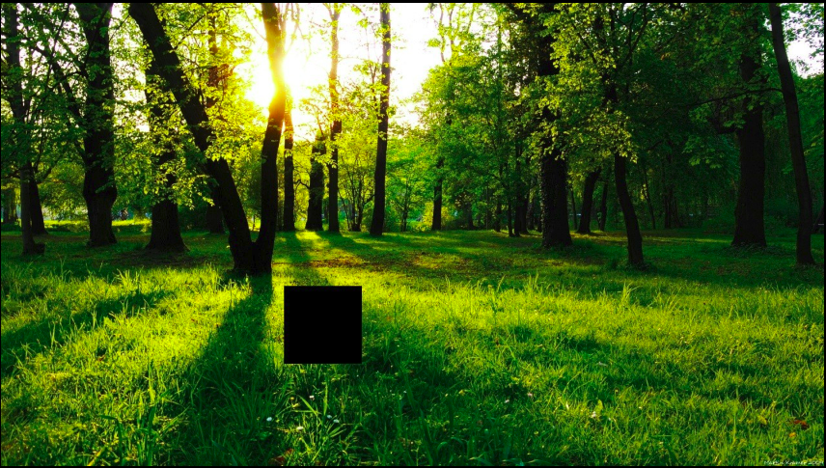

Patch filled image:



Due to non-uniform shadow patterns on the grassland, it could not match perfectly.

Application to image inpainting:

1.Input image:

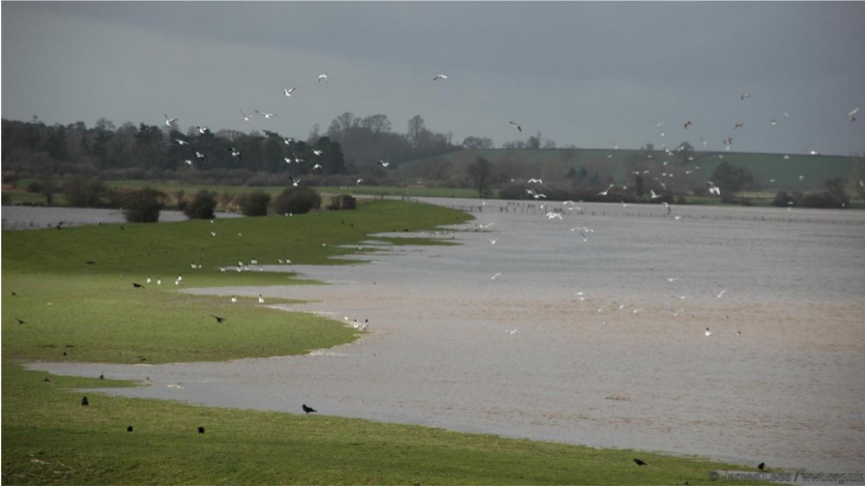

Patch created:

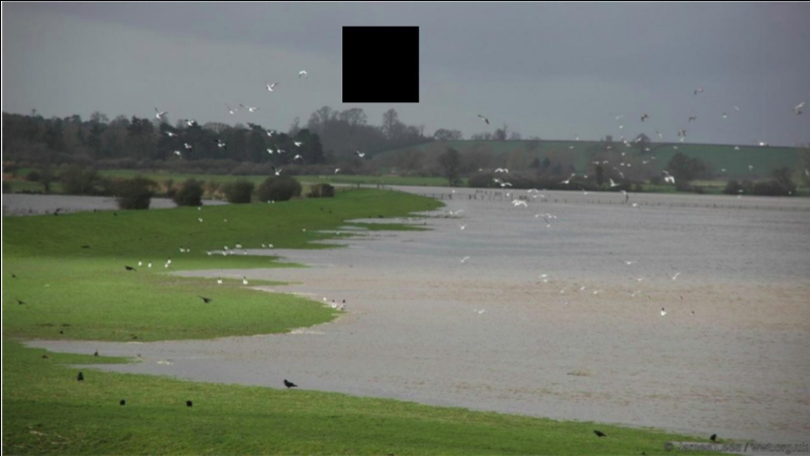

Patch filled:

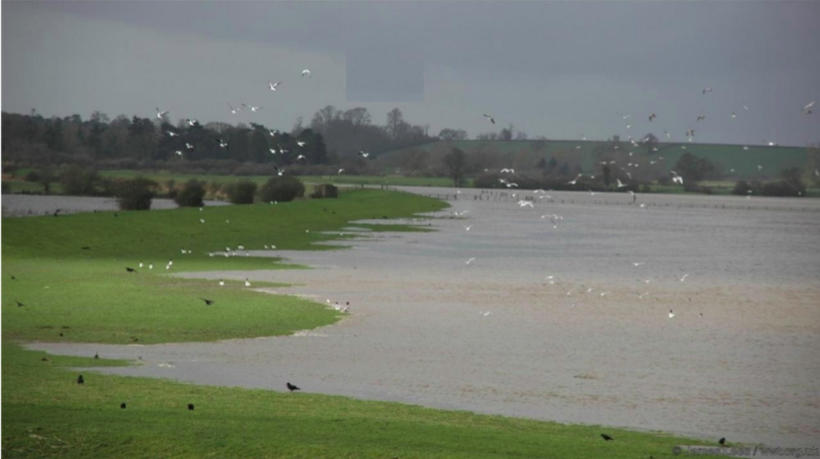

2.Input image:

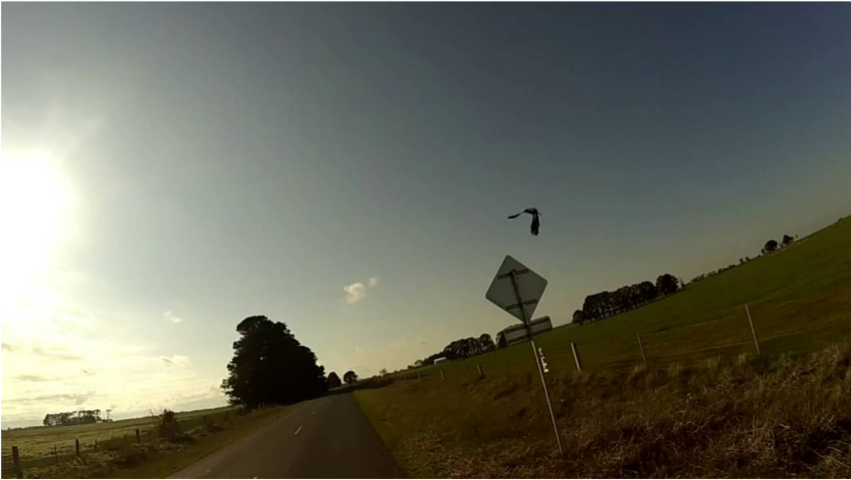

Patch created in image:

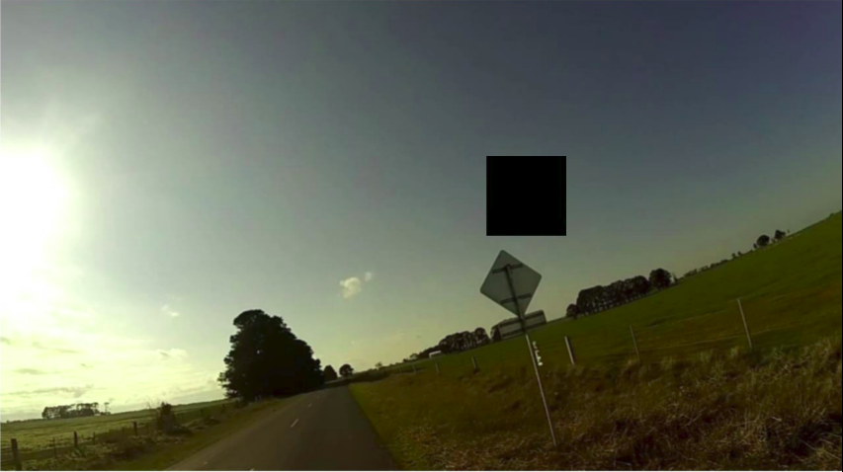

Patch filled in the image:

